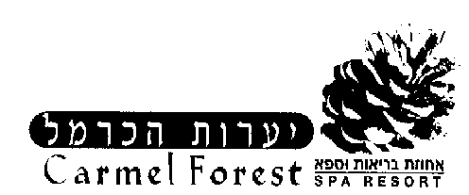
Treatment Reservations Request Form

The Carmel Forest Spa Resort offers a wide variety of treatments for the mind, body and soul.
In order to gain the maximum effect from your stay with us it is advisable to reserve the treatment you would like in advance of your arrival, and we will do our best to reserve them.
Please list the treatments you require and your preference for a male or female therapist. Please also note on the form if you have any medical or health problem regarding treatments, or if you are pregnant and in which week.
It is advised to reserve treatments at least two weeks prior to arrival.*

Last name _______________ Reservations No: _________________ Date of arrival: ______________

Name | Treatment requested | Day & hours requested | Therapist M or F | Medical problem

where no preference for Male or Female therapist is noted, the spa will reserve a therapist for you.-
please fill in your telephone number _____________ and your fax number for confirmations _____________.-
Please send this treatment form to fax: 04-8307899 and make sure to receive confirmation by fax return.-
Treatment reservation by telephone can be done from Sunday-Thursday between 09:00-18:00, 04-8307858.
Please note that if we can not reserve the treatment or the hour requested, we will do our best to make an alternative booking close to your preference.
Please make sure to read the confirmation fax carefully.

Thank you,
Treatments Reservations Department.

